***Dt : 23/9/2022***

***Summary of Arrays:***

***1.Array holding WrapperClass objects***

***2.Array holding String Objects***

***3.Array holding User defined class objects***

***4.Array holding Array Objects(Jagged Array)***

***5.Array holding Dis-Similer Objects(Object Array)***

***===========================================================***

***Assignment:***

***wap mto read and display Multiple Student details with result using***

***Arrays.***

***rollno name branch totMarks per result***

***=============================================================***

***Dis-Advantage of Arrays:***

***=>Array Size once defined cannot be modified at runtime or execution***

***time,because of this reason Arrays are not preferable to hold dynamic***

***data.***

***Note:***

***=>Dis-Advantage of Arrays canbe overcomed using Collection<E>***

***Framework.***

***=========================================================***

***\*imp***

***Relations in Java:(Inter Communications in Java)***

***=>The process of establishing communication b/w components is***

***known as Relations in Java or Inter Communications in Java.***

***=>Relations in Java are categorized into three types:***

***1.References***

***2.Inheritance***

***3.InnerClasses***

***1.References:***

***=>The process in which one object holding the reference of another***

***object is known as references concept,which is also known as 'Inter***

***Linking of Objects'.***

***Advantage:***

***=>The members of one object can use the members of another object***

***using reference.***

***Ex:***

***Contact.java***

***package test;***

***public class Contact {***

***public String mailId;***

***public long phNo;***

***}***

***Employee.java***

***package test;***

***public class Employee {***

***public String id,name,desg;***

***public Contact ob;//reference variable of type Contact***

***public Employee(Contact c) {***

***ob=c;***

***}***

***public String toString() {***

***return id+"\t"+name+"\t"+desg+"\t"+ob.mailId+"\t"+ob.phNo;***

***}***

***}***

***DemoRef1.java(MainClass)***

***package maccess;***

***import java.util.*;***

***import test.*;***

***public class DemoRef1 {***

***public static void main(String[] args) {***

***Scanner s = new Scanner(System.in);***

***Contact c = new Contact();***

***Employee e = new Employee(c);***

***//reading input using Employee object***

***System.out.println("Enter the EmpId:");***

***e.id = s.nextLine();***

***System.out.println("Enter the EmpName:");***

***e.name = s.nextLine();***

***System.out.println("Enter the EmpDesg:");***

***e.desg = s.nextLine();***

***System.out.println("Enter the EmpMailId:");***

***e.ob.mailId = s.nextLine();***

***System.out.println("Enter the EmpPhNo:");***

***e.ob.phNo = s.nextLong();***

***//display using Employee Object***

***System.out.println(e.toString());***

***s.close();***

***}***

***}***

***Diagram:***

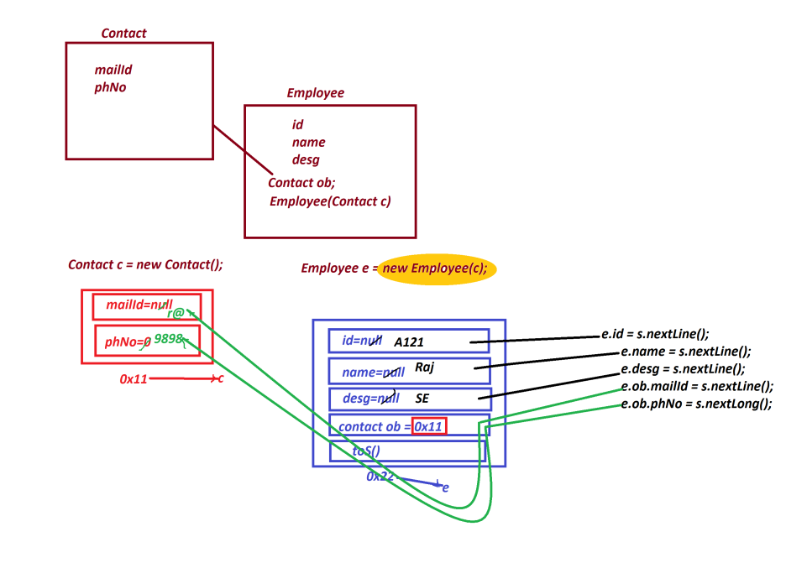

***================================================================***

***Ex-2 :***

***wap to read and display multiple employee details using Array and***

***the concept is 'references'.***

***Ex:***

***Contact.java***

***package test;***

***public class Contact {***

***public String mailId;***

***public long phNo;***

***}***

***Employee.java***

***package test;***

***public class Employee {***

***public String id,name,desg;***

***public Contact ob;//reference variable of type Contact***

***public Employee(Contact c) {***

***ob=c;***

***}***

***public String toString() {***

***return id+"\t"+name+"\t"+desg+"\t"+ob.mailId+"\t"+ob.phNo;***

***}***

***}***

***DemoRef2.java(MainClass)***

***package maccess;***

***import java.util.*;***

***import test.*;***

***public class DemoRef2 {***

***public static void main(String[] args) {***

***Scanner s = new Scanner(System.in);***

***System.out.println("Enter the number of employees:");***

***int n = Integer.parseInt(s.nextLine());***

***Employee a[] = new Employee[n];***

***System.out.println("Enter "+n+" Employee details:");***

***for(int i=0;i<a.length;i++)***

***{***

***a[i] = new Employee(new Contact());***

***System.out.println("Enter the EmpId:");***

***a[i].id = s.nextLine();***

***System.out.println("Enter the EmpName:");***

***a[i].name = s.nextLine();***

***System.out.println("Enter the EmpDesg:");***

***a[i].desg = s.nextLine();***

***System.out.println("Enter the EmpMailId:");***

***a[i].ob.mailId = s.nextLine();***

***System.out.println("Enter the EmpPhNo:");***

***a[i].ob.phNo = Long.parseLong(s.nextLine());***

***}//end of loop***

***System.out.println("====Employee details====");***

***for(Employee e : a)***

***{***

***System.out.println(e.toString());***

***}//end of loop***

***s.close();***

***}***

***}***

***o/p:***

***Enter the number of employees:***

***3***

***Enter 3 Employee details:***

***Enter the EmpId:***

***A111***

***Enter the EmpName:***

***Raj***

***Enter the EmpDesg:***

***SE***

***Enter the EmpMailId:***

***r@gmail.com***

***Enter the EmpPhNo:***

***9898981234***

***Enter the EmpId:***

***A222***

***Enter the EmpName:***

***Ram***

***Enter the EmpDesg:***

***TE***

***Enter the EmpMailId:***

***rm@gmail.com***

***Enter the EmpPhNo:***

***7676761234***

***Enter the EmpId:***

***A456***

***Enter the EmpName:***

***Alex***

***Enter the EmpDesg:***

***Al@gmail.com***

***Enter the EmpMailId:***

***6565651234***

***Enter the EmpPhNo:***

***6767671234***

***====Employee details====***

***A111 Raj SE r@gmail.com 9898981234***

***A222 Ram TE rm@gmail.com 7676761234***

***A456 Alex Al@gmail.com 6565651234 6767671234***

***===========================================================***